Blue Rock School Journals
10/08/09
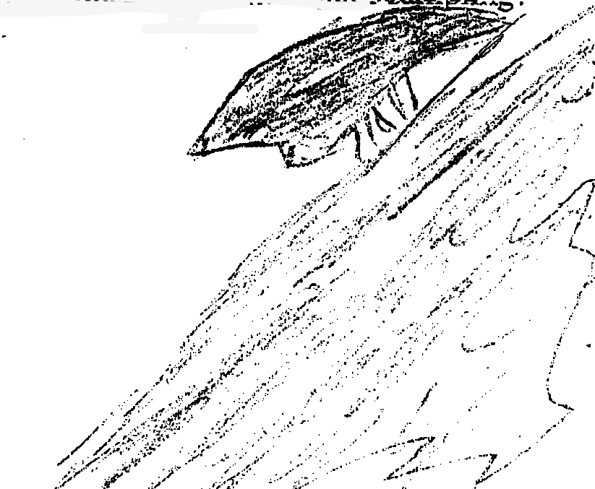
Drawing of ‘The Bug’

Found an extremely rare bug that looks like a thorn, fly and spider all together. It is very extraordinary.
By Michael Caccioppo

I loved the view of Westchester County. I liked seining and water chemistry. By India June

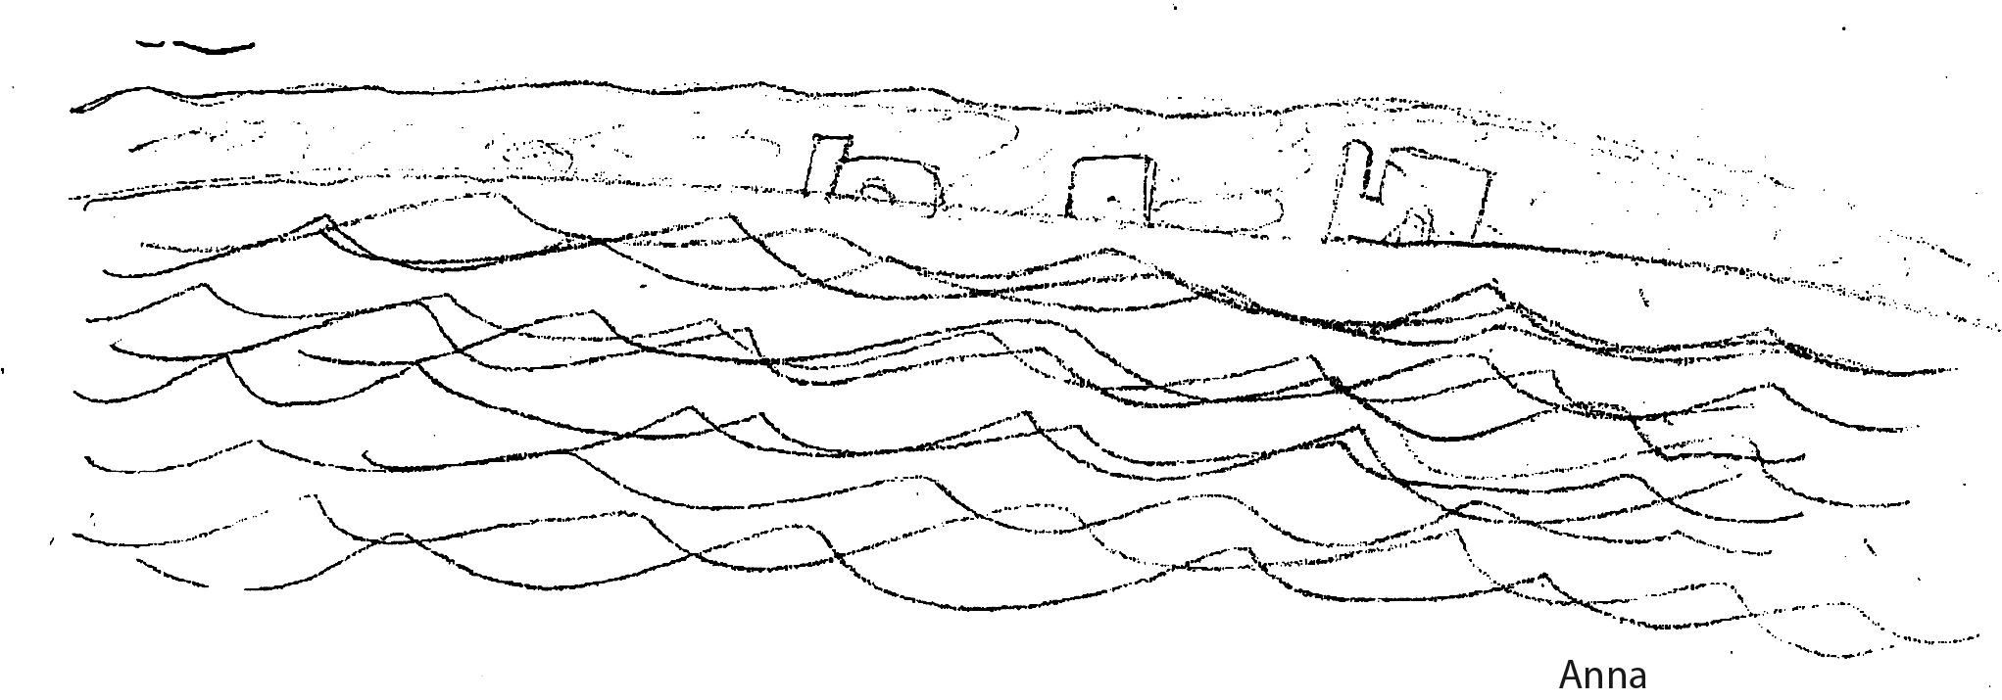

I’ve always been interested in tides. The thought that the tides move in and out, while also moving side by side, mesmerizes me. When I first found out that the moon controls the tide, I didn’t quite believe it, and it’s still hard to imagine. Something so far away, something that seems like it couldn’t possibly have anything to do with the water is so powerful that it controls the tides.

The thing is, I still don’t really get how. I’ve heard many people tell me, but I want the who, what, when, why and hows – not just the formal answer. I want to know, but I also think that leaving it mostly a mystery has a special spark to it.

Our river trip has inspired me. It has inspired me to find our more about the tide. Just not too much to take away the mysterious part. By Anna Stern

